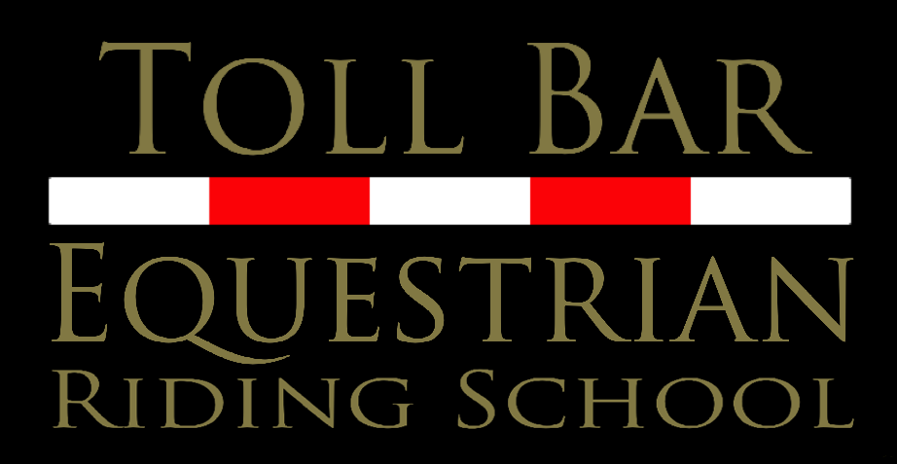
28 January 2022
Lesson Booking and Cancellation Policy

Booking:
Full Payment to be made for lesson at the time of booking. Your lesson is not confirmed until payment is made. For regular riders, this will mean paying a lesson in advance
Payment to be made by BACS with lesson day and time as the reference

Cancellation of lesson:
We operate a strict 24hr cancellation policy. Lessons must be cancelled atleast 24hrs in advance
Lessons cancelled with less than 24hrs notice will not be refunded
Please cancel by telephone 07497 777543 - either call or text (please check that your text sends). Our yard is busy and we often do not have the time or technology available to check emails, messenger messages, etc.
We operate in an outdoor school and ride in the rain and cold weather. Lessons cannot be transferred or refunded due to inclement weather.
In weather that is unsafe to ride in, lessons will be held on Lloyd, our Racewood simulator. If you do not wish for this or require more information, then please let us know when booking your lesson. Lioyd is an invaluable training tool when used alongside regular lessons.
Cancellation due to Covid 19 - Unfortunately we have experienced large numbers of cancellations due to the seasons and new variants of the virus. For this reason we now have to include late cancellations due to Covid into our cancellation policy for the riding school to remain viable and operational.

